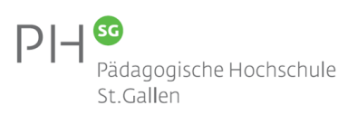**Presented by**

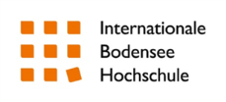**Supported by**

**International Early Childhood Education Research Conference - Quality & Professionalisation**

University of Education Weingarten, Germany, April 11th-13th 2018

**Conference Registration Form**

Please fill in the appropriate details and choices for the Conference and email to [conference-ecer-2018@ph-weingarten.de](mailto:conference-ecer-2018@ph-weingarten.de). Registration forms are available on the PH Weingarten website:   
<http://www.ph-weingarten.de/elementarbildung/Veranstaltungen.php>

Registration Contact: S. Mayr  
 conference-ecer-2018@ph-weingarten.de  
 Phone: +49 751 501-8388  
 University of Education  
 Kirchplatz 2, 88250 Weingarten, Germany  
 [http://www.ph-weingarten.de](http://www.ph-weingarten.de/)

|  |  |
| --- | --- |
| **Contact Information** | |
| **Title:** |  |
| **Name:** |  |
| **Institution:** |  |
| **Address:** |  |
| **Country:** |  |
| **E-Mail:** |  |
| **Phone:** |  |

|  |  |
| --- | --- |
| **Registration Fee** | |
| **Please check appropriate box:** | **50,00 Euro – Regular Fee** |
| **25,00 Euro – PhD-students** |
| **12,00 Euro – Ba-/MA-students** |

|  |  |
| --- | --- |
| **Optional Programme / Extras:** | |
| **Guided tour of Basilica Weingarten** | **Register me for the guided tour.** |
| **Local kindergarten visit** | **Register me for the kindergarten visit (only 20 spots available!).** |
| **Student Dinner (11th April 2018, 7.30 p.m.)** | **Register me for the student dinner (self-pay).** |

**Please send registration fee by bank transfer to:**

**Landesoberkasse Baden-Württemberg  
IBAN: DE02600501017495530102  
BIC: SOLADEST600  
Payment reference: 9879220104629 / ECER-Tagung**

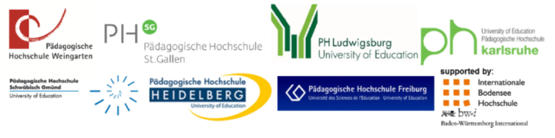**Please note that your registration will not be completed before transfer/receipt of your registration fee (payment within two weeks after registration via form).** THE PAYMENT REFERENCE „9879220104629 / ECER-Tagung“ MUST BE STATED ON YOUR BANK TRANSFER, OTHERWISE YOUR TRANSFER CANNOT BE ASSIGNED ACCORDINGLY