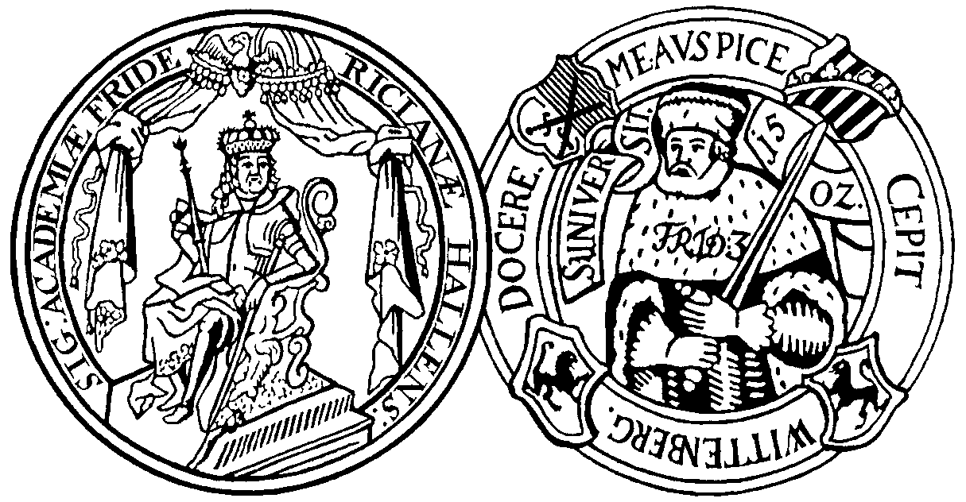**Martin-Luther-Universität**

**Halle-Wittenberg**

**Institut für Biologie/Zoologie**

Halle, 04.04.2024

On **Wednesday** **24th April 2024** **at 13:00** there will be a presentation in English by:

**Dr. Roberto Cozatl and Michael Hoffert**

from the University and State Library of Sachsen-Anhalt followed by feedback in **Seminar-Room (Raum 2.07) on the 2nd floor of Hoher Weg 8 (North Wing)** on the topic:

# “Open-Access and Open Science at the MLU”

Roberto Cozatl (Head of the Open Science Team) and Michael Hoffert (subject specialist for Biology) will be there to answer your questions on this topic. This is a meeting open to all in Zoology at MLU.

RJ Paxton