**INTERNATIONAL GRADUATE SYNTHESIS EDUCATION AND RESEARCH OPPORTUNITY**

**An area of conflict: the effects of agricultural subsidization on conservation goals worldwide**

**Project Summary**

The **Helmholtz Research School ESCALATE** at the Helmholtz Centre for Environmental Research (UFZ) (Germany), the **University of Leeds** (UoL) (UK), and the **National Socio-Environmental Synthesis Center (SESYNC)** at the University of Maryland (UMD) (USA) are partnering to invite applications from highly qualified PhD students interested in an international collaborative synthesis research experience.

The goal of this new partnership is to enhance graduate-level synthesis training and capacity building for students working at the intersections of socio-environmental systems. By bringing together European and American cultures of PhD education and providing a genuine interdisciplinary research experience, this effort will blend and build upon previous efforts independently led by all three partner institutions (click [here](https://www.sesync.org/for-you/educator/programs/graduate-programs) for more information about the Graduate Student Program at SESYNC and [here](http://www.ufz.de/index.php?en=43669) for details about the Helmholtz Research School ESCALATE).

Over a period of approximately 12 months, participating students will have the opportunities to:

* + Work and bridge divides in an international and highly diverse team
  + Build and apply synthesis knowledge and skills in a real-life setting
  + Collaboratively design a study, conduct research, and publish results
  + Contribute empirical results to an important topic of debate
  + Create a sustainable international network of young scholars interested in socio-environmental issues such as nature conservation, sustainable farming/food systems, and ecosystem services

**Project Description**

The international synthesis project is organized around a series of **three workshops**. The assembled team will examine feedbacks and linkages between agricultural subsidization and conservation goals in and around protected areas worldwide (e.g. Natura2000, Ramsar sites, National Parks, etc.). Specifically, the project will synthesize connections between ecological protection and/or restoration sites, literature on agricultural subsidization (e.g. EU Common Agricultural Policy), and data on agricultural yields and revenues. The exact research questions, data sources, and methodologies will be developed collaboratively at Workshop #1 based on the interests and skillsets of participating students.

***Background Information***

Globally, direct subsidies represent one of the largest budgetary influences on the agricultural market with the EU and USA spending more than 70 billion USD annually on direct subsidies. Apart from their effects on global food prices and international trade, agricultural subsidies are also regarded as having negative environmental implications. For example, the monoculture system associated with subsidized large-scale production has been implicated as a contributory factor in Colony Collapse Disorder which has affected bee populations. Bee pollination is an essential ecosystem service for the production of many varieties of fruits and vegetables. Subsidies often go towards lowering the cost of meat production, which has other nutritional and environmental implications for which subsidies do not account.

Protected areas worldwide serve the purpose of conserving natural ecosystems and biodiversity, but also to allow humans to experience and explore these regions and the inherent wildlife. Furthermore, there are increasing calls to conserve/enhance ecosystem services (“New Conservation”) provided by protected areas, thereby altering the purpose of protected areas. Amidst the competing pressures of delivering a variety of ecosystem services and the potential negative effects of surrounding agriculture, the primary goal of conservation areas (i.e. to protect wildlife) is trading off with human needs.

Several research directions will be explored during the kick-off workshop, and participants will make a consensus decision as to the direction the study will ultimately take. The research questions listed below are examples of potential topics to explore:

1. *What are generalizable trade-offs (measurable as an effect size) between the agricultural use (as indicated by subsidies) of protected areas (or in the surroundings) and reaching the conservation goals, and are these tradeoffs detectable across protected sites worldwide?*
2. *How do temporal trends in species monitoring data within protected sites (e.g. national parks) worldwide relate to land-use or land cover change in the surrounding agricultural areas over time?*
3. *To what degree are agricultural policies (at sub-national level e.g. US state, EU countries) and conservation policies/programs in alignment, and how do such alignments or misalignments manifest ecologically?*

***Timeline and Design***

* Application deadline: 31 January, 2019
* Acceptance offers: on or before 28 February, 2019
* Kick-Off Workshop in Leeds, UK (5 days): 8-12 April, 2019 (tentative)
* Second workshop in Leipzig, Germany (5 days): 14-18 October, 2019 (tentative)
* Third workshop in Annapolis, USA (5 days): 23-27 March, 2020 (tentative)
* Submission of jointly authored manuscript(s): on or before 1 May, 2020

The three workshops are consecutively scheduled for April 2019 (Leeds, UK), October 2019 (Leipzig, Germany), and March 2020 (Annapolis, USA). All expenses for European students’ travel and subsistence will be covered by ESCALATE. SESYNC will cover costs for all participants from University of Maryland. Applicants must be able and willing to commit to international travel. **Participation in all three workshops is mandatory.**

Over the course of the project, participants will learn about team science and leadership, synthesis research design, collaborative project management, and best practices in reviewing previous scholarship, synthesizing primary and secondary data, and collaboratively drafting research products. Participants will also submit **at least one manuscript to an international peer-reviewed journal**, whereby all active participants will be listed as co-authors.

**Workshop 1** will take place at the University of Leeds and the Selside–Yorkshire Dales Outdoor Adventure Centre in April 2019. Workshop 1 will begin with a focus on team building with outdoor activities (e.g. rock climbing, caving) and skills training (e.g. team science, communication, leadership) before shifting to project design and development. It will end with fairly solidified group project(s) that use a data- and/or literature-driven synthesis approach to investigate subsidization-conservation linkages. Key concepts will be discussed, a vision statement will be written, a clear research plan will be formulated, individual work packages will be developed, and synthesis tasks will be assigned.

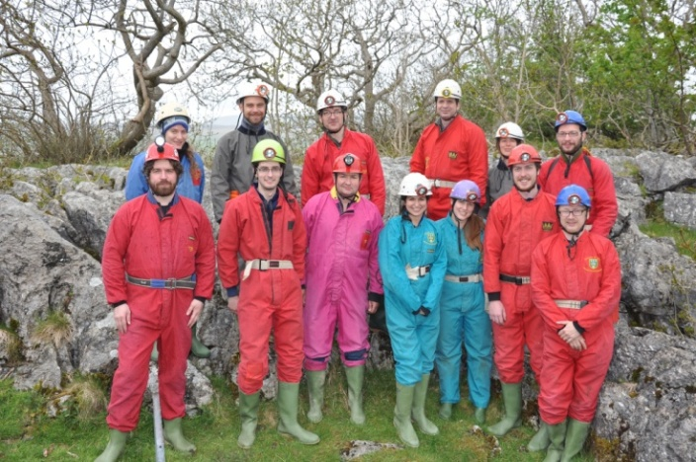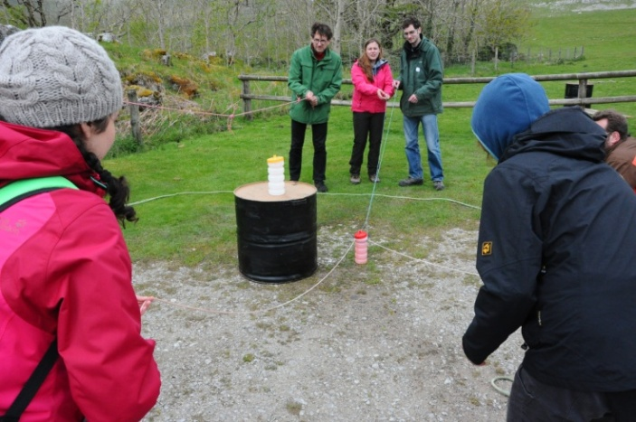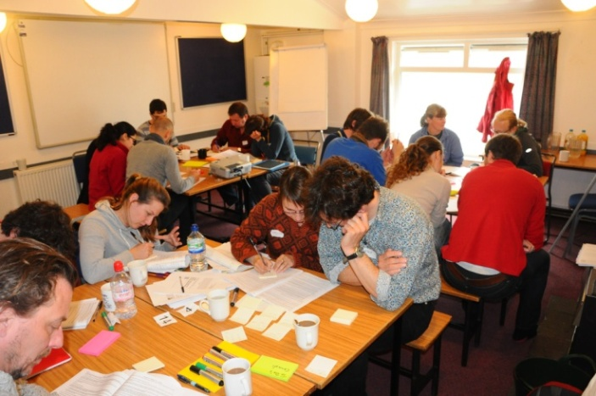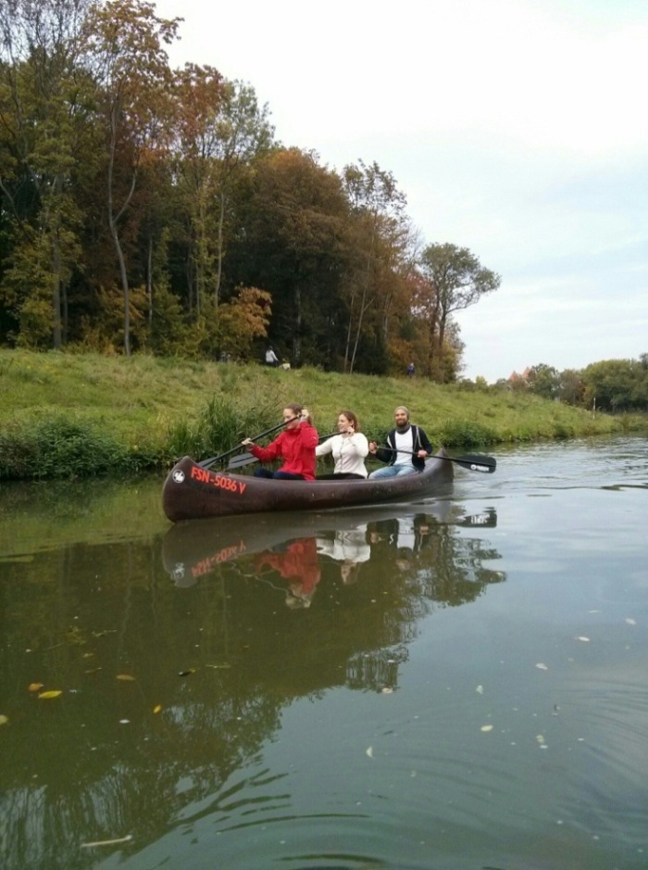

**Activities during previous ESCALATE Synthesis Projects held in 2017 and 2018.  
Top row:** Team building experience at the Selside Outdoor Centre of the University of Leeds. **Bottom row:** Brainstorming research questions at the Selside during the first workshop. Canoeing tour through the city of Leipzig during a second workshop of a previous synthesis project.

Between Workshops 1 and 2, participants will examine key scholarly works and original data following methods and guidelines agreed upon in the first meeting. Data will be acquired, analyzed, and synthesized in line with the project’s research questions. Participants will distribute tasks according to skills and interests and will regularly remain in touch via Skype to discuss progress, answer questions, monitor workloads, and ensure participation does not disrupt individual doctoral research projects. **The expected workload for the literature review, data extraction, and preliminary analysis is about 60 hours per participant within the first five-months period**.

**Workshop 2** will commence in October 2019 at the UFZ in Leipzig, Germany. In Leipzig, we will focus on discussing the synthesis of relevant literature and data sources, addressing any analytical or data challenges, interpreting preliminary data analyses, and generating additional results. We will also begin to frame and outline the resulting research paper, with potential ideas for a second research paper discussed as needed. Workshop 2 will continue the hands-on mentoring approach between students and advisors and include group and self-reflections on the collaborative synthesis process and on ways to maximize the likelihood of project success. Workshop 2 will end with restructuring and re-distributing tasks accordingly.

In between Workshops 2 and 3, participants will continue to advance the analysis, synthesis, and writing of one or more paper drafts as agreed upon during the second meeting. Regular Skype calls will continue during this period. **The expected workload for the final analysis and manuscript(s) drafting is about 40 hours per participant within the second five-months period**.

**Workshop 3** will be held in March 2020 at SESYNC in Annapolis, Maryland, United States. Workshop 3 will act as a capstone meeting to reflect upon challenges, opportunities, and best practices when working as part of interdisciplinary and international research teams. This final meeting will also focus on finalizing writing and publishing project results. In addition to pushing-out any other synthesis research products (databases, web tools, etc.), we will also discuss how to make project results actionable and available to a wider non-scientific audience such as US and European agriculturalists and decision-makers. Workshop 3 will help further solidify and celebrate this diverse network of young scholars with activities like a cruise on the Chesapeake Bay.

**Project Participants**

This project is led and supported by Drs. Ralf Seppelt (UFZ), Michael Beckmann (UFZ), Nicole Motzer (SESYNC), Jonathan Kramer (SESYNC), and Guy Ziv (University of Leeds). Up to four PhD students from each of the three partnering institutions will be invited to participate for a total of 12. PhD students from diverse disciplinary backgrounds (including social and natural sciences, humanities, law, etc.) are encouraged to apply. Work throughout this project will be closely supported by 2-3 staff members and researchers from the three partner institutions.

**How to apply**

Please complete the Expression of Interest form (pasted below) and send via email to Michael Beckmann ([michael.beckmann@ufz.de](mailto:michael.beckmann@ufz.de)). Please also include with your email an updated CV. **Applications are due** **no later than 16:00 Berlin time** on **31 January, 2019**.

We will notify you on or before 28 February, 2019 as to whether your application has been successful. The selection of the candidates will be based on the information provided in the Expression of Interest and on the suitability and complementarity of individual skill-sets and experiences. Stage of degree will also be given consideration, with preference given to students with **at least one year** of completed doctoral studies.

For questions about the application process, University of Maryland students should email Nicole Motzer ([nmotzer@sesync.org](mailto:nmotzer@sesync.org)) and University of Leeds students should contact Guy Ziv ([g.ziv@leeds.ac.uk](mailto:g.ziv@leeds.ac.uk)).

Expression of Interest Form

**This form must be submitted to** [**michael.beckmann@ufz.de**](mailto:michael.beckmann@ufz.de) **no later than 16:00 Berlin time on January 31 2019. Regrettably, we are unable to consider late submissions.**

Name:

Institutional affiliation:

E-mail:

Why are you personally interested in this project? (less than 100 words)

What do you hope to gain from your participation? (less than 200 words)

What unique expertise / skills you will bring into the team? (less than 200 words)

What one (1) research question would you suggest for this project, and how? (less than 300 words)

*Please do not copy/paste from our list. We hope to get a diversity of questions / methodologies that we will elaborate on during the kick-off workshop. We pay the greatest attention to demonstrated critical thinking and effort in answering this question when selecting participants to the project. Obviously, you don’t need to detail a fully worked-out methodology – but we want to see some effort towards realistic (i.e. achievable) research questions!*