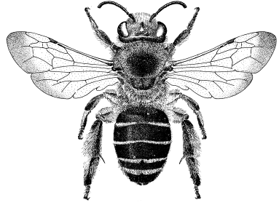European Bee Course

Application Form

Name:

Sex: Male [ ] Female [ ] (check one).

Food: Non-vegetarian: [ ]; Vegetarian [ ]; No red meat [ ] (check one).

Professional address:

Position:

Highest university degree, year granted:

Phone number: E-mail address:

Emergency contact (name, email address, phone number):

On a separate page with your name on top, please supply a paragraph detailing the reason(s) for wishing to take course.

Please ask someone who knows you and your interest in the course to send an e-mail message in support of your application to: denis.michez@umons.ac.be

The COURSE is limited to 15 participants. Selection of participants will be carried out by committee and based on your reasons for wishing to take the course at this time.

PLEASE SEND THIS APPLICATION TO: [denis.michez@umons.ac.be](mailto:denis.michez@umons.ac.be)

DEADLINE FOR APPLICATION: February 1, 2018

You will be advised of receipt of the application and will be notified of your acceptance to the Course by February 3, 2018.